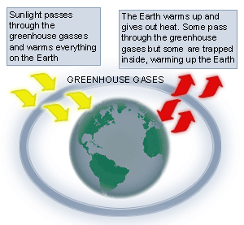**Name ______________ October_______**

**Investigating Climate Science - Lesson 2**

**Today in T.A.D., we . . .**

. . . examined and analyzed recent editorial cartoons.

. . . discussed possible causes of changing climates and identified which were *anthropogenic* and

which were natural.

. . . learned how *greenhouse gases* such as *carbon dioxide, methane, nitrous oxide*

and *water vapor* get into our atmosphere and how they create the *greenhouse effect.*

. . . participated in an investigation to observe the effects of carbon dioxide on temperature

. . . predicted how a change in our climate may affect our *infrastructure*, our *economy*, *wildlife*

and *agriculture*.

**In order to be prepared for our next T.A.D. class on ___________________:**

Use the attached matrix, think about how a change in climate may affect each of these categories. Consider BOTH **positive** and **negative** effects of a climate change. Use the following link to research further effects located around the world. This link is also found on the T.A.D. website under the tab “Homework Help.”

<https://archive.epa.gov/climatechange/kids/expeditions/index.html>

**Visit our T.A.D. website for more information and activities relating to Climate Science!** <http://tadclimatescience.weebly.com/>

Be sure to sign and return the permission slip for our upcoming trip to Janes Island!

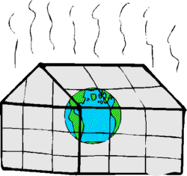

**________________________**

Parent Signature